# Deploy SOCA 2.7.2 in China Regions

1. 在ZHY or BJS region開一台Amazon Linux 2 EC2 instance做為SOCA installer. 截圖以ZHY region為例.

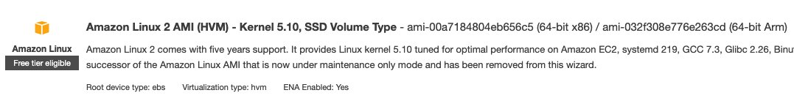

1. 登入SOCA installer by ssh or session manager, 下載SOCA 2.7.2 安裝包: <https://mylab-soca.s3.cn-northwest-1.amazonaws.com.cn/soca2.7.2.tar.gz> 並解開:

# sudo su -

# wget <https://mylab-soca.s3.cn-northwest-1.amazonaws.com.cn/soca2.7.2.tar.gz>

# tar -zxvf soca2.7.2.tar.gz

# cd scale-out-computing-on-aws/installer

1. SOCA installer需掛載instance profile賦予足夠權限執行SOCA部署. 詳細IAM policies在檔案“installer/SOCAInstallerIamPolicy.json". 若為測試目的可掛載”[AdministratorAccess](https://console.amazonaws.cn/iam/home#/policies/arn:aws-cn:iam::aws:policy/AdministratorAccess)” role.
2. 執行aws configure設定ZHY為default region. 不需輸入AKSK.

# aws configure

AWS Access Key ID [None]:

AWS Secret Access Key [None]:

Default region name [None]: cn-northwest-1

Default output format [None]:

1. 執行pip3 install補齊套件. (若有需要)

# pip3 install -i <https://opentuna.cn/pypi/web/simple> boto3 colored requests

1. 在installer目錄下執行./soca_installer.sh. 這時會開始初始化python virtual environment. 因為在中國區對外安裝pip的關係,你有非常大概率會碰到time out erro如下截圖所示. 執行步驟7進入virtual environment手動安裝以排除錯誤

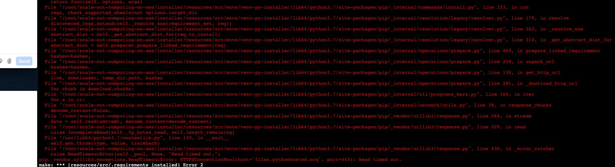

1. 執行命令進入virtual environment並進行pip3 install. 執行完pip3安裝所需套件後退出virtual envrionment回到installer目錄再次執行./soca_installer.sh

# source resources/src/envs/venv-py-installer/bin/activate

(venv-py-installer) # pip3 install -i <https://opentuna.cn/pypi/web/simple> —upgrade pip

(venv-py-installer) # pip3 install -i <https://opentuna.cn/pypi/web/simple> -r resources/src/requirements.txt

1. 完成步驟7補齊套件後, 重新執行./soca_installer.sh 應可成功進入SOCA installer互動介面如下. 便可依據問題輸入參數開始安裝SOCA. CDK驗證成功後便開始deploy cloudformation stack. 等待40-60分鐘SOCA部署完畢

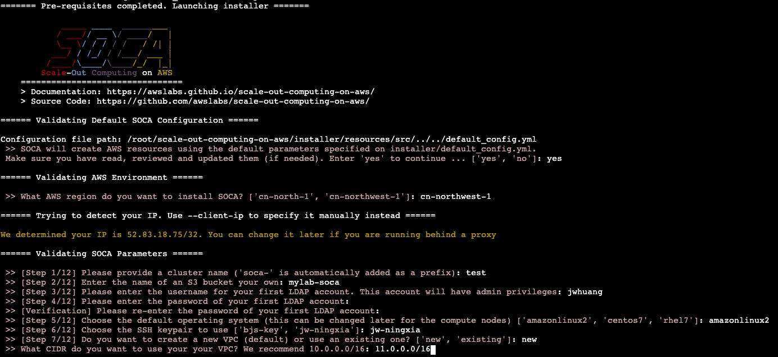

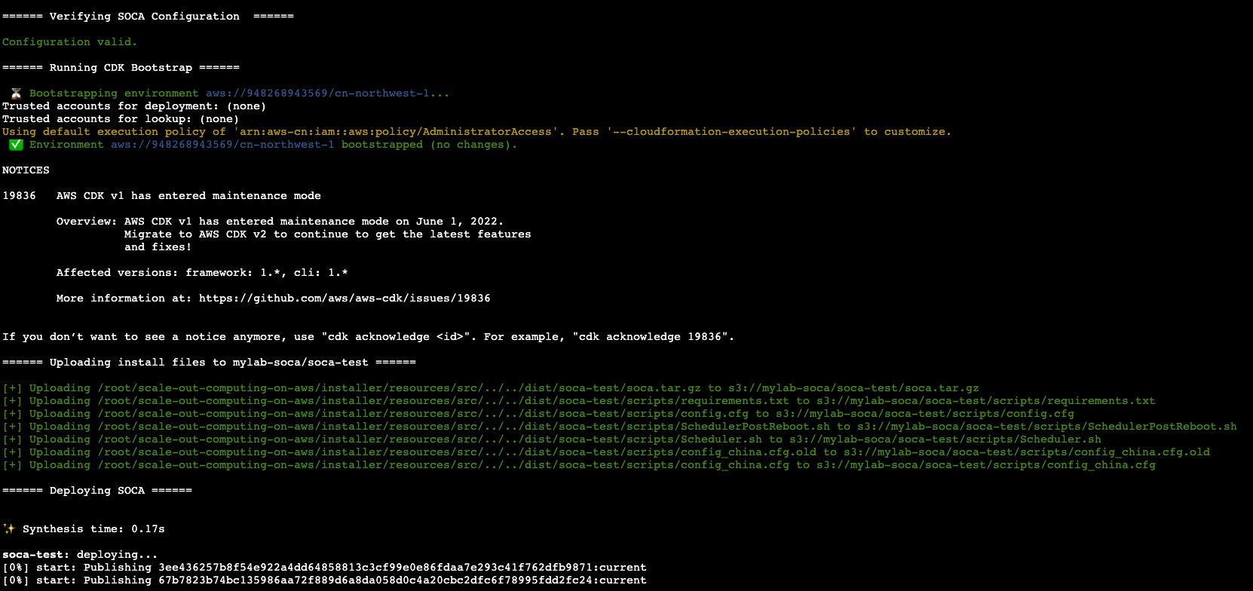

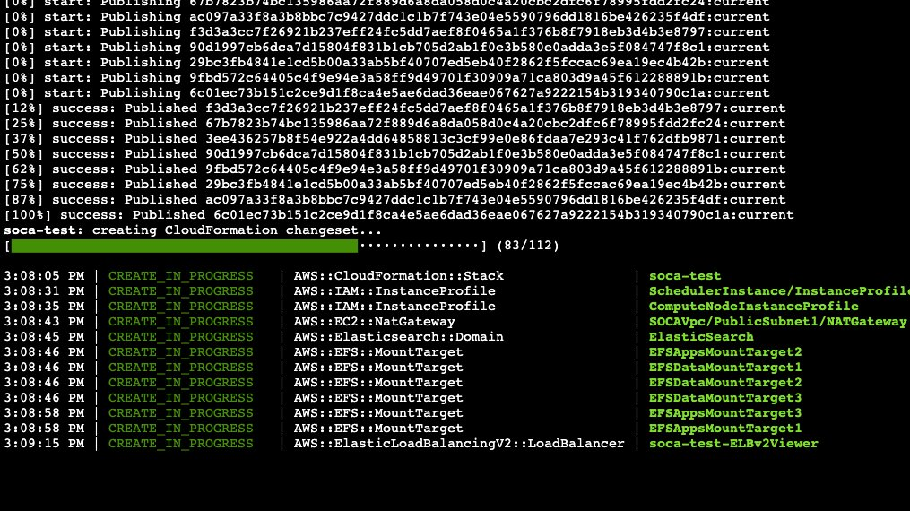

1. SOCA部署時會依據installer IP設定security group inbound rules. 根據需求修改security group允許22, 80, 443 ports登入

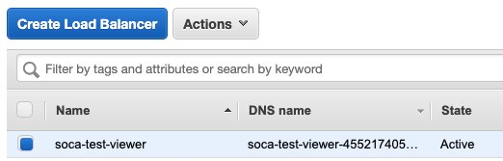

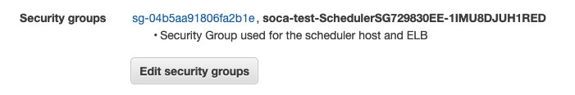

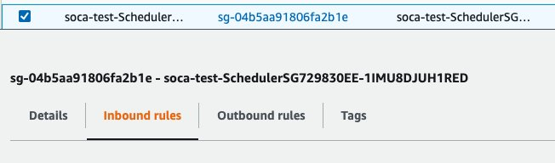

1. CFN部署完畢後從Outputs取得SOCA Web URL登入SOCA. 若碰到502 error可能為SOCA post install尚未完成. 再等待一些時間即可登入。

